TZX 听力高频 题目版
1听力还原集Vol.6-Test 2-Part1 Bakewell Travel: Customer Booking Request Form 3
2听力还原集Vol.9-Test2-Part 4 The role of sleep in humans and animals 4
3听力还原集Vol.9-Test 4-Fish Farming 6
4听力还原集Vol.9-Test1-Part1 House Cleaning Service 8
5听力还原集Vol.9-Test1-Part4 Graphical Symbol 9
6听力还原集Vol.8-Test 3-Part1 Full Refund 11
7听力还原集Vol.7-Test 4-Part2 Global Museum 13
8听力还原集Vol.7-Test 3-Part1 Student Accommodation 15
9听力还原集Vol.7-Test 3-Part4 The History of Umbrellas 16
10听力还原集Vol.7-Test 2-Part1 School Art Competition 17
11听力还原集Vol.7-Test 2-Part2 Walking Holiday 18
12听力还原集Vol.7-Test 2-Part4 American Salt Marshes 20
13听力还原集Vol.7-Test 1-Part1 Beechen Festival 22
14听力还原集Vol.7-Test 1-Part4 Food Safety Standards 23
15听力还原集Vol.6-Test 4-Part1 Manor Farm 24
16听力还原集Vol.6-Test 4-Part4 Benefits of using drama activities in the classroom 26
17听力还原集Vol.6-Test 1-Part1 Amateur Dramatic Society 27
19听力还原集Vol.6-Test 1-Part3 Archaeology Course 29
20听力还原集Vol.5-Test1-Part1 Speedway Removal Company Booking Form 30
21听力还原集Vol.5-Test1-Part4 Development and use of plastics 31
22听力还原集Vol.5-Test2-Part1 Rental Property Application Form 32
23听力还原集Vol.5-Test2-Part4 The Berbers 33
24听力还原集Vol.5-Test3-Part1 Birthday party arrangements 35
25听力还原集Vol.5-Test3-Part2 Stanley Island 36
26听力还原集Vol.5-Test3-Part4 Extinction of Species 38
27听力还原集Vol.5-Test4-Part1 Winsham Farm 40
28听力还原集Vol.4-Test1-Part1 London Relocation Services 42
29听力还原集Vol.4-Test1-Part4 Recycling Tyres in Australia 43
30听力还原集Vol.4-Test2-Part1 Two-bedroom apartment 45
31听力还原集Vol.4-Test2-Part4 Early gold mining in the Otago region, New Zealand 46
32听力还原集Vol.4-Test3-Part1 Dunedin Medical Centre 48
33听力还原集Vol.4-Test3-Part4 Research in child psychology 49
34听力还原集Vol.4-Test4-Part1 Kiwi Air Customer Complaint Form 50
35听力还原集Vol.4-Test4-Part4 Photic sneezing 51
36听力还原集Vol.7-Test 3-Part2 Home Improvement Store Plan 53
37听力还原集Vol.7-Test 1-Part2 Information for participants in the Albany fishing competition 55
38听力还原集Vol.7-Test 1-Part3 The placement for science teaching 57
39听力还原集Vol.6-Test 4-Part3 Presentation on how products are marketed differently for boys and girls 59
40听力还原集Vol.5-Test1-Part2 Bridge to Brisbane Fun Run 61
41听力还原集Vol.4-Test1-Part2 Talk to new employees at a strawberry farm 63
42听力还原集Vol.4-Test2-Part3 Product development presentation: mosquito net 65
43听力还原集Vol.4-Test3-Part2 Information for Volunteers at Clifton Bird Park 67
44听力还原集Vol.4-Test4-Part2 Gym 69
45听力还原集Vol.9-Test3-Part 3 Discussion on Nursing Course 71
46听力还原集Vol.8-Test 1-Part2 Photography club 73
47听力还原集Vol.7-Test 3-Part3 Oral History 74
48听力还原集Vol.7-Test 2-Part3 Shampoo Marketing Project 76
49听力还原集Vol.6-Test 4-Part2 A talk by a fire safety officer 78
50听力还原集Vol.6-Test 3-Part2 Visiting Marelia 80
51听力还原集Vol.6-Test 3-Part3 Environmental science course 82
52听力还原集Vol.6-Test 2-Part2 The Middletown Urban Farming Scheme (MUFS) 84
53听力还原集Vol.6-Test 2-Part4 Effect of digital world on young 86
54听力还原集Vol.5-Test2-Part2 Queensland Festival 88
55听力还原集Vol.5-Test2-Part3 Peter De Wint 91
56听力还原集Vol.5-Test3-Part3 Geology field trip to Iceland 94
57听力还原集Vol.5-Test4-Part3 A survey on music students 96
58听力还原集Vol.4-Test1-Part3 Career Mentoring Programme 99
59听力还原集Vol.4-Test2-Part2 Gisborne 101
60听力还原集Vol.4-Test3-Part3 Research for assignment of children playing outdoors 103
61听力还原集Vol.4-Test4-Part3 Field trip to Bolton lsland 105
62听力还原集Vol.5-Test1-Part3 Education House 108
63听力还原集Vol.5-Test4-Part2 The Beach Races 110

1听力还原集Vol.6-Test 2-Part1 Bakewell Travel: Customer Booking Request Form
Questions 1 – 10
Complete the notes below. Write NO MORE THAN TWO WORDS AND/OR A NUMBER in each gap.
Bakewell Travel: Customer Booking Request Form
Travelling to: Dubai
Name: Sarah Carter
Contact phone number: ______ (two double two)
Best day to call: ______ morning
Number of people traveling: ______
Date of outward journey: ______
Date of return journey: 25 November
Purpose of trip: a ______
Special requirements: one passenger can’t eat ______
Market Research
Number of trips in last 12 months: six
Last country visited: ______
Purpose of last foreign trip: ______
Customer feedback on web: too ______
Email address: carter.s@ ______.com

2听力还原集Vol.9-Test2-Part 4 The role of sleep in humans and animals
Questions 31-40
Complete the notes below.
Write NO MORE THAN TWO WORDS for each answer.
The role of sleep in humans and animals
Importance of sleep in animals
• Compared to those without food, animals without sleep are more likely to suffer from 31. ______
• Sleep is necessary for all animals, whether they are reptiles, 32. ______ or fish.
Differences in animals’ sleep and reasons for their ways of resting
Dolphins
• swim to the surface when sleeping, because they need to 33. ______
Birds
• are constantly 34. ______in the presence of numerous predators.
Horses
• do most of their sleeping standing up.
• do occasionally take short naps lying down. Lying in one position for a long time could well injure a horse, because their 35. ______ are delicate.
Potential problems encountering
• Animals can also have 36. ______, the same as humans.
Importance of sleep in humans
• It helps us to organise our 37.______ of the day.
• It plays a key role in 38. ______
e.g.
• Because of the similar sleeping pattern to that in humans, 39. ______ are studied in order to increase our knowledge of human physiology.
• Scientists choose to study the 40. ______ of the fruit fly in order to know the function of the human gene and understand developmental processes in humans.

3听力还原集Vol.9-Test 4-Fish Farming
Complete the notes below.
Write ONE WORD ONLY for each answer.
Fish Farming
Local fish farmers are afraid that genetically modified fish will 31. ______ into the sea.
• like to breed fish with special features, like 32. ______
• other solutions:
- to build some cages to prevent the fish from 33. ______
- to use 34. ______ nets to support the frames of the cages
Problems facing the local fishermen:
• lack of land on the 35. ______
• lack of 36. ______ fish
Initiatives taken by the government:
• encourages fish farmers to 37. ______local fish farming business
• helps fish farmers to sell seaweed and oyster:
- Seaweed can be used to make 38. ______
- Oyster is a source of seafood which can supply local 39. ______ industry.
• saves local fishing business by encouraging aquaculture, recreation and 40. ______

4听力还原集Vol.9-Test1-Part1 House Cleaning Service
Questions 1-4
Complete the notes below.
Write ONE WORD ONLY for each answer.
HOUSE SERVICE INFORMATION
Example Answer
Name: Barbara Hill
Location: 1. ______ London
Postcode: SW105
Rooms: two 2. ______ rooms
The other room used as an 3. ______
Downstairs: kitchen-diner, conservatory, and 4. ______
Pets: 2 dogs and 3 cats
Questions 5-7
Choose the correct letter, A, B, or C.
5Which of these extra services does the customer agree to do?
Change the bed linen
Do some gardening work
Clean the glass
6What does the customer want cleaned every three months?
Curtains
Carpets
Mats
7What does the customer want done with clothes?
Wash and iron the clothes
Iron the clothes
Clean and dry the clothes
Questions 8-10
Complete the sentences below.
Write ONE WORD AND/OR A NUMBER for each answer.
The agent’s address is 12 8. ______ Road.
Her house will get cleaned next 9. ______
The maximum time of cleaning service is 10. ______ hours.
。

5听力还原集Vol.9-Test1-Part4 Graphical Symbol
Questions 31-36
Complete the notes below.
Write ONE WORD ONLY for each answer.
GRAPHICAL SYMBOL
‘Graphical symbol’
• includes the logographs in Egyptian hieroglyphic writing and ancient Chinese pictograms
• found in Africa, the Americas, and Oceania
• still has something to do with 31. ______use today
Ancient graphic writing systems
• Researchers obtain a wide range of 32. ______ about past civilisations.
- Rosetta Stone was found in 1799 when members of Napoleon’s expedition got to Egypt.
- Frenchman Jean-François Champollion determined the phonetic values of the symbols in 1822.
• In those symbols, 33. ______ are used to depict various meanings.
Camera obscura
• 34. ______ helps people understand history better.
• Some charities will 35. ______many endangered species.
• A camera was tied to one 36. ______ a bird.
Questions 37-40
Complete the sentences below.
Write ONE WORD ONLY for each answer.
More 37. ______ will be included in the future with the development of photography.
Companies would like to invest a lot to advertise in 38. ______.
Designing appealing 39. ______ is used as a way of effective branding.
Graphic writing systems are of great importance in the subject of 40. ______.

6听力还原集Vol.8-Test 3-Part1 Full Refund
Questions 1-4
Complete the notes below.
Write NO MORE THAN TWO WORDS AND/OR A NUMBER for each answer.
Product Incident Report
Example Answer
Product: rice cooker
Model Number: 1. ______
Price of the Product: £ 2 ______
Name of the Branch: 3. ______
Problem: 4. ______
Questions 5-10
Complete the notes below.
Write NO MORE THAN THREE WORDS AND/OR A NUMBER for each answer.
Customer's Information Details
Name: Herbert Hewitt
Address: 5. ______
Postcode: 6. ______
Method of Payment: 7.______
Card’s Expiry Date: 8.______
Method of Compensation: 9.______
Shopping Frequency: 10.______

7听力还原集Vol.7-Test 4-Part2 Global Museum
Questions 11 - 18
Choose the correct answer.
11The Heritage Clothes exhibition was put together by
museum staff.
local residents.
clothing manufacturers.
12The photographs show the clothes worn by
their owners.
professional models.
design students.
13The exhibition called Toys from the Past is
displayed in a new gallery.
on show for a limited time.
aimed specially at children.
14Visitors to Toys from the Past are recommended to
play with the toy trains.
look at all the dolls.
see the board games.
15The miniature toys have been
made by the museum.
bought by the museum.
borrowed by the museum.
16The biscuit factory made tins
for people all over the world.
of different shapes.
for many famous people.
17People’s favourite biscuit used to be
an unsweetened one.
one covered in chocolate.
one filled with cream.
18The hands-on activity allows people to
make some biscuits.
taste some of the biscuits.
pack a biscuit tin.
Questions 19 - 20
Complete the sentences. Write NO MORE THAN TWO WORDS in each gap.
The gift shop is located beside the ______ on the ground floor.
Free ______ are available for visitors’ belongings.

8听力还原集Vol.7-Test 3-Part1 Student Accommodation
Questions 1 - 10
Complete the table. Write NO MORE THAN TWO WORDS AND / OR A NUMBER in each gap.
Student Accommodation
Type | Cost | Contract
College：single room | Standard:￡3276 per year  En-suite: ￡______ per year | 36 weeks  (Rooms not available during the______)
______ : Room with a family | ￡150 per week-all inclusive | Arrangements are ______
Private renting: room in a  shared house or ______ | From ￡275 to ￡490 per month  Additional costs（for this year）  •gas and electricity ￡______ per  month approx  • ______:￡9  • ______ | 6 months  Need  • ______  •Two ______

9听力还原集Vol.7-Test 3-Part4 The History of Umbrellas
Questions 31 - 40
Complete the notes. Write ONE WORD ONLY in each gap.
The History of Umbrellas
Symbolism and Status
• Umbrellas symbolized ______ for rulers, showcasing authority.
• Only wealthy Roman ______ could own umbrellas, a status symbol.
Materials and Construction
• In India, umbrellas were made from local ______ and in China from silk.
• Umbrellas were treated with ______ to make them waterproof, improving their usefulness.
Practical Enhancements
Originally, umbrellas were designed to protect the ______ from various elements
• Early umbrellas resembled big ______ providing extensive coverage.
• Umbrellas were often used with gloves especially in cold or wet climates.
• The introduction of ______ in the 1850s made umbrellas lighter and more durable.
• In England, umbrella frames began to be made with ______, enhancing their durability.
• In Germany, the shift to using ______ for umbrellas improved their functionality and popularity.

10听力还原集Vol.7-Test 2-Part1 School Art Competition
Questions 1 - 4

Complete the table. Write ONE WORD AND / OR A NUMBER in each gap.
School Art Competition
Arrangements for this year
Age group | Theme | Type of art | Prize
Junior students | ______ | a drawing | ______ tickets
Senior students | the ______ | a photograph | a ______voucher

Questions 5 - 10
Complete the notes. Write ONE WORD AND / OR A NUMBER in each gap.
Further details
Submitting the artwork
• When: no later than ______
• Where: at the ______
Competition judge
• Name: Rebecca ______
• Her phone number: ______
After the judging
• The display will be in the Bridge Street Gallery.
• The artworks will appear in a ______ produced by the school.
• The art exhibition will be followed by a ______

11听力还原集Vol.7-Test 2-Part2 Walking Holiday
Questions 11 - 14
Choose the correct answer.
11Approximately how many passengers does the ferry hold?
160
600
2000
12Which items should the tourists pack in a separate bag?
food
reading material
medicines
13The hostel in La Vega de Liebana has
good washing facilities.
a games room.
a number of single bedroom
14Residents at the hostel are not allowed to
take furniture out of the hostel building.
enter the hostel after a certain time
smoke in the hostel gardens.
Questions 15 - 17
Complete the notes. Write NO MORE THAN TWO WORDS in each gap.
Clothes and equipment
Bring:
boots with thick soles
spare socks
light waterproofs
suncream: strength – total block
a plastic folder for map, etc.
Questions 18 - 20
Choose THREE correct answers.
18-20
Which THREE of the following features of the area in Spain does the speaker talk about?
altitude
coastline
economy
geology
temperatures
vegetation
wildlife

12听力还原集Vol.7-Test 2-Part4 American Salt Marshes
Questions 31 - 34
Complete the sentences. Write ONE WORD ONLY in each gap.
American Salt Marshes
The salt content in marshes can be as high as that of the ______.
At different times of the day, there are changes in salinity and in the ______ and warmth of the water.
Animals such as worms and shrimps feed on the ______that grow in the marsh.
Marshland in the US has been used in the past for______ cultivation.
Questions 35 - 38
Choose the correct answer.
35The speaker says that one result of erecting artificial walls in salt marshes is that
water levels can get too high.
wildlife has less space.
water quality is difficult to control.
36Some people have complained about the building of dikes because
access for walkers is reduced.
the insect population has increased.
the natural beauty of the area is affected.
37In the 20th century, a large proportion of marshes in America became
salt extraction sites.
residential areas.
protected insect reserves.
38There are now laws which help to prevent
the erosion of soil.
the building of more walls.
the extinction of sea life.
Questions 39 - 40
Complete the notes. Write NO MORE THAN TWO WORDS in each gap.
The Horseshoe Crab
Related to: spider
Most common food: ______
Time of year when female lays eggs: ______

13听力还原集Vol.7-Test 1-Part1 Beechen Festival
Questions 1 - 6
Complete the table. Write ONE WORD AND / OR A NUMBER in each gap.

Beechen Festival
Date | Time | Activity | Place | Comments
June 19th | 7 p.m. | concert | the _______
June 20th | _______  p.m. | tour | meet at the _______ | includes a visit to  an old flour mill
June 21s | all day | children's _______  competition | Beechen Community  Centre | bring a _______
June 21st | evening | fireworks | by the _______

Questions 7 - 10
Complete the notes. Write ONE WORD AND / OR A NUMBER in each gap.
This year, activities end by _______ p.m.
There won’t be any _______ in the town centre this year.
The festival’s web address is www. _______ . com.
Festival organisers would like to receive _______ online.

14听力还原集Vol.7-Test 1-Part4 Food Safety Standards
Questions 31 - 40
Complete the notes. Write ONE WORD ONLY in each gap.
Food Safety Standards
Risk assessment
• Scientists have to consider potential problems with:
• the product's _______ (could they attract harmful bacteria?)
• method of preparation (will it eliminate harmful micro-organisms?)
• how products are _______ and distributed
• supermarkets (e.g. changes in _______ affecting the condition of frozen food)
• end-users (how is food usually handled in the home?)
Factors affecting food consumption
Legislation
Consumer attitudes
• e.g. dislike of additives→growth of the _______ food market in Australia
The food industry
• supermarkets may use price or _______ as their selling strategy (but the main concern is profitability)
The mass media
• now the main source of _______ for many
• negative effect because not objective:
concern for _______
news is now a form of _______ which can mislead the public
• few programmes deal with food safety or _______
Personal opinion
Importance of education: as with benefits of exercise, many children can influence their _______

15听力还原集Vol.6-Test 4-Part1 Manor Farm
Questions 1 - 3
Complete the form. Write NO MORE THAN TWO WORDS in each gap.
Manor Farm
Application Form – Summer fruit picking
Name: Ben Miller
Country of origin: the USA
Age: 20
Visa type: a _______
Visa valid until: November
Availability for work: from _______ to October
Heard about job: from the _______
Questions 4 - 10
Complete the form. Write NO MORE THAN THREE WORDS AND / OR A NUMBER in each gap.
Manor Farm
Important information for fruit pickers
Picking season:
Busiest month is _______
Exact picking dates depend on the _______
Payment:
Pickers over 18 will earn £ _______ an hour
Accommodation:
None on the farm but there is a _______ nearby
Transport:
Pickers are advised to travel around by _______ .
Documentation:
Only pickers with a _______ will be allowed to work
Meals:
Pickers must bring lunch and a day's supply of _______.

16听力还原集Vol.6-Test 4-Part4 Benefits of using drama activities in the classroom
Questions 31 - 40
Complete the notes. Write ONE WORD ONLY in each gap.
Benefits of using drama activities in the classroom
Child's personal development
• Group participation develops _______ in own ideas.
• Unscripted, imaginative activities allow children to take _______
Child's educational development
• Working as a group teaches the importance of _______ to others.
• Performing makes children _______ for their learning and behavior.
Role-play can be used:
• as a form of _______
• For children experiencing problems
• to help children be objective about their behaviour problems
• to explore controversial issues with a class in a _______ environment
• to explore children's self-knowledge and understanding of _______
Advantages of using role-play in the study of history
• Drama activities increase children's _______in class
• Makes it easier for children to _______ and understand historical events
• Can find answers to _______ in history to see why certain decisions were made

17听力还原集Vol.6-Test 1-Part1 Amateur Dramatic Society
Questions 1 – 10
Complete the notes below. Write ONE WORD AND/OR A NUMBER in each gap.
Amateur Dramatic Society
Secretary: Jane Caulfield
Mailing address: 117 Green Road, Prestwin
Location for rehearsals: The _______ House, Wynn
No experience necessary
They need actors and _______ singers
Also need people who can _______
Meetings 6–8 p.m. every _______
Closed in _______ (for 2 weeks)
Membership costs:
Standard: £ 40 (includes a _______ once a year)
Over 60s or unemployed: £ _______
Youth group: for people aged _______ years old and under
Shows:
● mostly plays by _______ authors
● family show in December
(raises money for children's _______)

18听力还原集Vol.6-Test 1-Part2 Spring Festival
Questions 11 - 18
Complete the table. Write NO MORE THAN TWO WORDS AND / OR A NUMBER in each gap.
Spring Festival
Event | Location | Date and Time | Other Information
Firework display | Near the _______ | 4 September  9 p.m. | Pack aand blanket
Display of _______ | Central Park | daily | Buses run from the town centre every _______ minutes
The _______Show | Exhibition Centre | 10–15 September  9 a.m. – 10p.m.
'Grow Your Imagination' | in the _______ | 11–19 September
'Swing in Spring' | in the _______ | 17&18 September | Saturday matinee  performance at _______

Questions 19 and 20
Choose the correct answer.
19In the Spring Festival competition, you can win
a family pass to 'Balloons Down Under'.
a cheque for $200.
a flight in a hot air balloon.
20You can get an entry form for the competition from
the radio station
the newspaper
the Festival's website

19听力还原集Vol.6-Test 1-Part3 Archaeology Course
Questions 21 - 30
Complete the notes. Write NO MORE THAN THREE WORDS in each gap.
Archaeology Course
• Can be combined with any other subject except _______
• Has three _______ modules in first semester
Module 1
Title: _______
Lecturer: Dr Morris
Learning method: Lectures and practical sessions
Content: Based on processes
• recording
• _______
• interpretation
• display
Assessment: By _______
Module 2
Title: _______
Lecturer: Prof. Elliot
Content: _______ and development of built environments
Assessment: By _______ examination
Module 3
Title: Method and Science
Lecturer: Dr Thompson
Content: Standard techniques in fieldwork and analysis
Learning method: 50% lab work, 50% _______
Site survey at end of module (the _______ is to be announced later)

20听力还原集Vol.5-Test1-Part1 Speedway Removal Company Booking Form
Questions 1 - 10
Complete the notes below. Write ONE WORD AND/OR A NUMBER in each gap.
Speedway Removal Company Booking Form
Client name: Grace Davies
Present address: 79, _______ Road
Moving to: Karori, so charge at the _______ rate
Booking reference: _______
Proposed date of move: January 26th
Special items in house:
- a lot of books
- a _______ collection
- furniture and a piano in the living room
- the _______ is NOT to be removed from the kitchen
- all furniture from bedrooms
Items from garden to be moved:
- a large _______
- the metal _______
Items from garage to be moved:
- lawn-mower
- a few _______
Type of insurance policy: the _______ cover
Access to property: key will be under the _______ by the back door

21听力还原集Vol.5-Test1-Part4 Development and use of plastics
Questions 31 - 40
Complete the notes below. Write ONE WORD ONLY in each gap.
Development and use of plastics
1930s
Polythene – two main forms:
● LDPE – distinguishing feature: it is highly _______
e.g. used to make _______ , carrier bags and packaging materials
● HDPE – made tougher by exposure to a particular kind of _______
– suitable for rigid containers, e.g. for bleach
Polyurethane – two main forms:
● blown form used for making _______ (padding)
and in housing infrastructure to give _______
● non-blown form used mainly for sportswear
1940s – 1950s
PET
– used to make _______ , e.g. Dacron and Terylene
– popular for making containers for fizzy drinks
– because it resists abrasion – used for household objects such as _______
Tupperware
– storage boxes
– revolution in _______ techniques
1960s
Teflon – non-stick
– almost no _______ , so used for protective coatings, e.g. for frying pans
Gore-Tex – best known for outdoor wear
– also used for various _______ purposes

22听力还原集Vol.5-Test2-Part1 Rental Property Application Form
Questions 1 - 10
Complete the form below. Write ONE WORD AND/OR A NUMBER in each gap.
Rental Property Application Form
Name: Susan Smith
Phone number: ______ (mobile)
Email address: susansmith@ ______ .com
Current address: 234 Becketts Road, Brisbane. 4054
New Zealand Employer: Auckland Hospital
Occupation: a ______
Rental start date: 8th February
Preferred property type:
• first preference: a house with a ______
• second preference: an apartment with a big ______
Bedrooms: two
Furnishings: a ______ is required
Maximum rent: $ ______ per week
Preferred location: near the ______
Other requirements:
must have ______ nearby
would like ______ included in the rent

23听力还原集Vol.5-Test2-Part4 The Berbers
Questions 31 - 40
Complete the notes below. Write NO MORE THAN TWO WORDS in each gap.
The Berbers
• lived in various countries in North Africa
• were driven from their homes during the 12th century
• began to lead a nomadic life, moving across ______and mountains
Different Berber Lifestyles
• Some Berbers, known as ______ nomads, moved twice a year.
• Some Berbers were completely nomadic.
• Some Berbers settled by oases, producing fruit, vegetables, and ______ to cook with.
• People and belongings were carried by ______
• Settled Berbers lived in houses.
• Nomadic Berbers used tents.
• Settled communities organised themselves by holding regular meetings in the ______of the village.
The Tuaregs
• If goatskins were unavailable, tents were made from ______ or palm-leaf mats.
• Tuareg labourers were the descendants of ______ .
• Adult men always wore a ______ veil.
• Some Tuaregs moved to Burkina Faso with their ______
Tuaregs and Timbuktu
• Timbuktu was settled by Tuaregs around 1000 years ago.
• The city built wealth on the salt and gold trades.
• Some Tuaregs now work as ______ for the Mallian Department of Tourism.

24听力还原集Vol.5-Test3-Part1 Birthday party arrangements
Questions 1 – 6
Which hotel offers the following facilities？Choose the correct answer and move it into the gap.
Birthday party arrangements
sea view
disabled access
indoor play area
choice of food
private dining room
group discount

Royal hotel
Star hotel
Winchester hotel
All three hotels

Questions 7 - 10
Complete the notes below. Write ONE WORD ONLY in each gap.
Things to do immediately
Send a ______ to the Winchester Hotel
Make the ______
Things to do later
Find out who needs help with ______
Tell people not to bring any ______

25听力还原集Vol.5-Test3-Part2 Stanley Island
Questions 11
Choose correct answer.
11At the present time, Stanley Island can be reached by
hovercraft
plane
ferry
Questions 12 – 15
Where can the following facilities and attractions be found?
Choose the correct answer and move it into the gap.
golf courses

family hotels
self-catering flats
nature walks
The North Coast
The South Coast
The East Coast

Questions 16 - 20
Complete the notes below. Write NO MORE THAN TWO WORDS in each gap.
Advice to Visitors
• Bring your own ______ and insect spray.
• It may not be possible to use your ______ in the western area.
• Don't drink water from ______ .
• Be careful of the ______ as they bite .
• Try the local ______ .

26听力还原集Vol.5-Test3-Part4 Extinction of Species
Questions 31 – 40
Complete the notes below. Write ONE WORD ONLY in each gap.
Extinction of Species
Recent problems in Australia:
• A species of parrot is under threat due to the production of wind energy.
• Several species of ______ are at risk because of increased housing.
• Loss of food source due to pesticides is affecting many animals, especially ______ .
• Production of single crops like ______ is harming wildlife.
Attitude to endangered animals:
• Can be influenced by the ______ (e.g. the panda).
• People are less concerned about smaller animals, e.g. ______
• Some animals are ignored because they are viewed
a) with ______
b) as our ______ in terms of food
c) with disgust
Reasons for preventing extinction:
• to improve our knowledge of the ecosystem
• the ecosystem needs to be ______ to be stable
• some types of ______ can help to signal environmental problems
• animals can help in medicine, e.g. :
a) improved well-being for people from having a pet
b) cobwebs help with medical disorders related to ______

27听力还原集Vol.5-Test4-Part1 Winsham Farm
Questions 1 - 8
Choose correct answer.
1The centre has enough accommodation for
18 people.
20 people.
38 people.
2The meeting room is currently
unavailable.
flooded.
booked.
3Visitors must tell the centre in advance if they want to
use the centre's kitchen.
have meals cooked for them.
eat at restaurants outside.
4All visitors on the tour of the farm can
get information about organic farming.
help to feed the animals.
watch a tractor demonstration.
5On the survival course people have to
learn to use map.
find their own food.
run through woodland.
6From the centre it is easy to walk to
the Exmoor National Park.
the beach.
a cycling route.
7If the weather is bad visitors can go to a
cinema.
theatre.
museum.
8Groups who wish to stay at the centre must pay
part of the cost in advance.
all of the cost in advance.
all of the cost on arrival.
Questions 9 and 10
Complete the notes below. Write ONE WORD AND/OR A NUMBER in each gap.
Address: Winsham Farm, ______ Road, near Sherborne
Post code: ______

28听力还原集Vol.4-Test1-Part1 London Relocation Services
Questions 1 – 10
Complete the form below. Write ONE WORD AND/OR A NUMBER in each gap.
London Relocation Services
Customer's name Anna Woods
Customer's personal details
● Current address: 118 ______ Park, Ballysillan
● Postcode: BT14 9BJ
● Phone no: ______ (mobile)
Other information
● Anna is hoping to find work as a ______.
● She needs to find a ______school for her son.
Requirements for the new property
Location:
● Her preferred location is in the ______ of the city.
● Her husband would like to be near a ______ .
● Her son would prefer to be close to a ______ .
Property details:
● She would like to live in a ______.
● She would prefer ______ bedrooms.
● A small ______ is also desirable.

29听力还原集Vol.4-Test1-Part4 Recycling Tyres in Australia
Questions 31 – 34
Complete the notes below. Write ONE WORD ONLY in each gap.
Recycling Tyres in Australia
Background
More than 1.5 million tyres dumped in Australia per ______
Previous recycling attempts failed because:
• there were pollution problems – smoke from burning
• recycling companies didn't make any ______
Advantages of Molectra's process
• More economical because smaller machines are used
• Less maintenance – tyres softened before shredding
• No limit on the ______ of tyres recycled
The Future
• Ten more factories being built
• Plans to spend 5% of income each year on ______
Questions 35 – 40

Complete the flow-chart below. Write ONE WORD ONLY in each gap.
Recycling Tyres

Process |  | Possible Uses
Removal of steel ______ from tyre rim | → | Steel pellets used in industry
↓
Chemicals applied to get rid of ______and soften rubber
↓
Fibres, e.g.nylon,removed | → | • Strengthening concrete  • Sheets made of ______ (= plastic panels)
↓
Tyres cut up into crumb rubber | → | • Asphalt for roads  • Insulation  • ______ tiles
↓
The MolectraVac machine microwaves rubber into hydrocarbon | → | i) Used for activated carbon  • ______ treatment  • air filtration  il) Used for carbon black  • batteries  • ______  ili) Oil used for electricity

30听力还原集Vol.4-Test2-Part1 Two-bedroom apartment
Questions 1 – 10
Complete the notes below.
Write ONE WORD AND/OR A NUMBER in each gap.
Two-bedroom apartment
The name of the owner is: Mary
Details of apartment
• The apartment will be available from June.
• The rent is $ ______ a month.
• The flooring in the apartment is made of ______ .
• There is not enough space for a dishwasher in the apartment.
• A ______is used to operate the laundry machines.
• It is OK to use ______ cookers on balcony.
• There is no locker to store a ______ , but there are racks.
Facilities and services in the apartment building
• The building has full-time ______.
• Free classes are held in the building's pool.
Appointment details
• Meet the owner at ______ pm on Monday
• Go to 236 ______ Road
• Take the bus west to the intersection and look for the ______
• Look for the building across from the ______

31听力还原集Vol.4-Test2-Part4 Early gold mining in the Otago region, New Zealand
Questions 31 – 34
Complete the notes below. Write ONE WORD ONLY in each gap.
Early gold mining in the Otago region, New Zealand
Background
1852: there was a brief gold rush
Late 1850s: local governments offered a ______ to experienced gold prospectors
May 1861: miner Gabriel Read found gold in a ______
Who took part in the gold rush?
• mainly young single men or men leaving families at home
• women opened ______ for the miners
• businessmen offered services, e.g. hardware stores and ______
What were early mining towns like?
At first, the buildings were made of canvas and timber, and later ______
What difficulties did miners face at the goldfields?
• the freezing temperatures and unexpected ______
• a poor diet of tea and ______
What benefits and problems did gold bring to the Otago region?
Growth of the Otago town of Dunedin led to complaints about:
- the increasing price of ______
- problems with sanitation
The gold also resulted in:
- investment in shipping
- the first New Zealand ______
- the need for experienced workers, in particular ______

32听力还原集Vol.4-Test3-Part1 Dunedin Medical Centre
Questions 1 – 10
Complete the notes below. Write NO MORE THAN TWO WORDS AND/OR A NUMBER in each gap.
Dunedin Medical Centre
Contact Details
Name: Henry lan ______
Date of Birth: ______ 1965
Address: ______
Phone Numbers: home: 293-8476
Other Details
Ethnic Group: ______
Residency Status: a New Zealand ______
Type of Card Holder: ______
Transfer of Records
Previous Medical Centre: ______ Hill
Located in: ______ Island
Assign to Doctor
Patient Preferences (If any): male doctor
hours: ______
specialism: ______
Register with: Dr. Chang

33听力还原集Vol.4-Test3-Part4 Research in child psychology
Questions 31 – 39
Complete the table below. Write NO MORE THAN TWO WORDS AND/OR A NUMBER in each gap.
Research in child psychology
past | present
Three aspects of development: social, cognitive, emotional. | These aspects now regarded as being ______.
Behaviour was studied in artificial contexts.  Example: ______  (was related to behaviour of animals in ______). | Awareness that child's behaviour is influenced  by his/her ______ and the situation she/she is in.
Child was seen as being ______.  Parents were held responsible for way child developed. | No direct link between early influences and child's ______
Influence of Piaget:  Young children were believed to be ______ | Influence of Harriet Reingold:  Examples show that children are aware of other people.
Psychologists did not take culture into account.  Example: importance of ______ for babies. | Guatemalan study - babies are kept in the ______  for first year → no effect on later development.

Questions 40
Choose the correct answer.
40The speaker thinks that one topic which will be examined closely in future is
the influence of the mother.
early speech patterns.
development before birth.

34听力还原集Vol.4-Test4-Part1 Kiwi Air Customer Complaint Form
Questions 1 – 10
Complete the notes below. Write ONE WORD AND/OR A NUMBER in each gap.
Kiwi Air Customer Complaint Form
Customer has been trying to make booking using the internet.
Booking details
Name: Janet ______
Ticket details: one adult and three children
(Wellington to Christchurch) – four ______ tickets
Flight dates: November 10th – 15th
Time: departing at ______ a.m.
Details of the problem
• the website changes the rate for one child
• the website keeps giving the customer ______ message
Customer informed that Kiwi Air policy：
• allows no more than ______ child fares per adult (applies to domestic flights only)
Customer's reasons for complaint
• none of her children are ______ years old or older
• child passengers require less ______
• the rule is unfair for large families and ______groups
Customer invited to send written complaint
• letter to go to the ______
• reply predicted within a week
• reference number: ______

35听力还原集Vol.4-Test4-Part4 Photic sneezing
Questions 31 – 40
Complete the notes below. Write ONE WORD ONLY in each gap.
Photic sneezing
Background
Some people react to sunlight by:
• a prickle in the nose
• faster _______ relieved by a sneeze
• watery eyes
This 'photic' sneeze cannot be controlled and is a _____ reflex.
Sneezing in general
• A sneeze is caused by some kind of irritation in the nose.
• Nerve endings in the ______are stimulated, leading to an explosion of air.
• It is co-ordinated by the same mechanism that controls the production of _____.
Research into photic sneezing
The condition has been known for thousands of years.
Aristotle: Why does the sun cause sneezing while a ______ does not?
Bacon showed the cause was light.
Everett found 80% of photic sneezers shared the habit with _______ .
Indicators
Photic sneezers usually produce the same times of sneezes.
The reaction is caused by a _______ in brightness.
The sneeze takes ______ to recharge.
Application
The condition was often ignored apart from some research on photic sneezing among _________ .
But studying it may result in breakthroughs for more serious conditions.

36听力还原集Vol.7-Test 3-Part2 Home Improvement Store Plan
Questions 11 -15
The map has eight labels (A - H). Choose the correct label for each building.
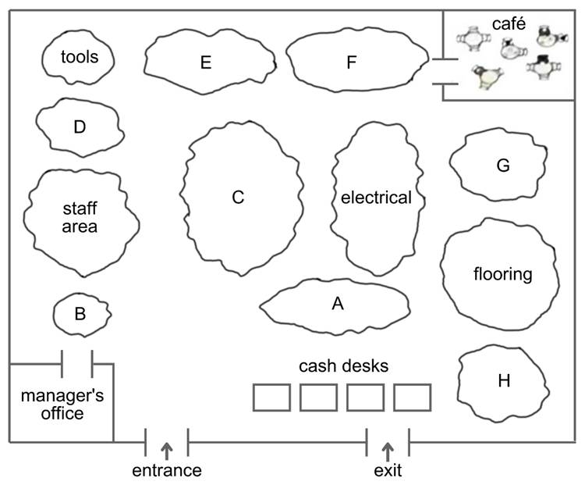
 | A | B | C | D | E | F | G | H
11 Paint
12 Kitchen
13 Children's play area
14 Shower and bath
15 Garden
Questions 16 - 20
Choose the correct answer.
16What makes the Home Improve Store special?
their low prices
their wide range of products
their customer service
17What should staff promote to customers?
the catalogue
the magazine
the website
18What do the current staff like best about working in the store?
the general staff discounts
the good atmosphere
the flexible working time
19What will the next workshop be about?
how to grow plants
how to fix a fence
how to paint a room
20What special deal does the company offer when people buy a new kitchen?
free appliances
free delivery
free installation

37听力还原集Vol.7-Test 1-Part2 Information for participants in the Albany fishing competition
Questions 11 - 14
Choose the correct answer.
11What do participants need to take to the registration desk?
a form of identification
a competitor number
cash for the entrance fee
12What does the entrance fee to the competition include?
equipment for fishing
all food for both days
fuel for the fishing
13Participants without a fishing license are recommended to apply for one
at the registration desk.
over the phone.
on the internet.
14What will happen at 6 pm on Sunday?
The time allocated for fishing will end.
The fish caught will be judged.
The prizes will be awarded to the winners.
Questions 15 - 20
The map has eight labels (A - I). Choose the correct label for each building.

Albany Fishing Competition Map
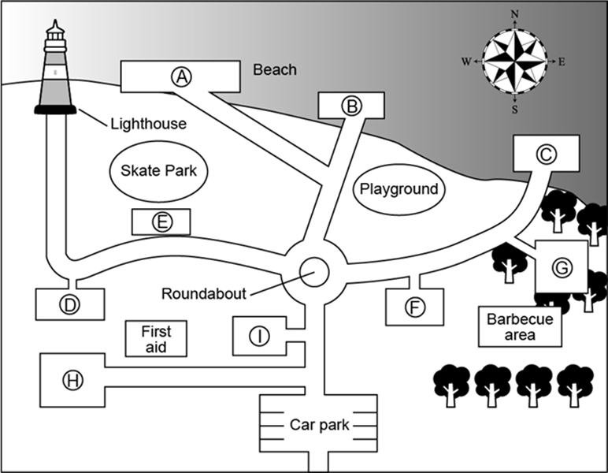
 | A | B | C | D | E | F | G | H | I
15 Registration area
16 Shore fishing area
17 Boat launching area
18 Judging area
19 Dining area
20 Prize-giving area

38听力还原集Vol.7-Test 1-Part3 The placement for science teaching
Questions 21- 26
Choose the correct answer and move it into the gap.

Subject of Experiments
Steam engine
Breakfast cereals
Bouncing balls
Making paper
Tie-dyeing
Glue from milk

Comments
very boring
too difficult
specialised equipment needed
very expensive
immediate results
useful practice for maths
cheap to do
takes longer than usual to do

Questions 27 -30
The diagram has seven labels (A - G). Choose the correct label for each part.

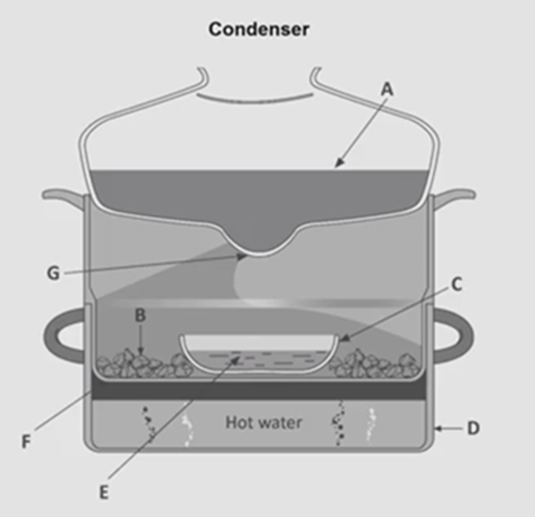
 | A | B | C | D | E | F | G
27 Metal container
28 Integral strainer
29 Drip tip
30 Pottery container

39听力还原集Vol.6-Test 4-Part3 Presentation on how products are marketed differently for boys and girls
Questions 21 - 24
Choose the correct answer.
Presentation on how products are marketed differently for boys and girls
21According to John, UK retailers who differentiate between boys' and girls’ products are
being forced to change this approach.
only responding to what customers want.
responsible for establishing a global trend.
22Annie believes most parents prefer children’s toys to be displayed according to
theme.
brand.
age group.
23When discussing Lise Eliot's book on gender roles, the students agree that
Eliot has overestimated the influence of advertising on children.
Eliot's book will be most popular within the USA.
Eliot makes some valid points within the book.
24In John's opinion, the problem of marketing toys according to gender is that a child's
social development will be delayed.
career options could become limited.
academic achievement will suffer.
Questions 25 - 30

The flow-chart has five gaps. Choose the correct answer and move it into the gap.
The development of gender-specific clothing in the US
It was because of _______ that children wore white clothes in the 19th century.
In the early 1900s, consumers were influenced by the choices of ________.
By the 1940s, shop owners believed that ________ were 'blue for boys' and 'pink for girls'.
In the 1960s, teenage girls believed that ________ could be beneficial to them.
The ______ of the 1980s meant that people felt pressure to shop for gender-specific clothing.
Nowadays, some mothers want their daughters to have ________ as they did not have these themselves.

parental preferences
technological advances
physical abilities
feminine clothes
advertising changes
unisex styles
well-known figures
practical reasons

40听力还原集Vol.5-Test1-Part2 Bridge to Brisbane Fun Run
Questions 11 - 14
Choose correct answer.
11On the day of the race the speaker recommends parking
in the sports ground.
by the river.
in the shopping centre.
12The timing chip should be attached to
the shirt or singlet.
a shoe.
the wristband.
13Which group will run first?
yellow
red
purple
14The race organisers still need to find volunteers to help with
giving first aid.
handing out water.
starting the race.
Questions 15 – 20
The map has eight labels (A – I). Choose the correct label for each building.
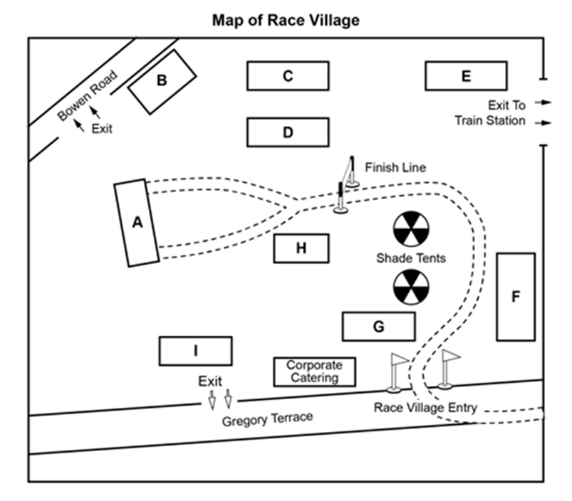
 | A | B | C | D | E | F | G | H | I
15 Stage
16 T-shirt Stand
17 Bag Collection Area
18 Information Centre
19 Prize Draw Box
20 Water station

41听力还原集Vol.4-Test1-Part2 Talk to new employees at a strawberry farm
Questions 11 – 14
Choose the correct answer.
11What should employees bring to work?
gloves
lunch
water
12If employees can't come to work one day, they should
contact the duty manager.
leave a phone message at the farm office.
call their team leader.
13One problem with customers that may occur now is that
they sometimes fail to return baskets.
they eat the fruit before paying.
they can be unsure about prices.
14One of the benefits of working at the strawberry farm is that
employees' friends are entitled to a small discount.
employees can have a quantity of fresh fruit for free.
employees don't pay the full price for gift items in the shop
Questions 15 - 20
The map has eight labels (A - I). Choose the correct label for each building.

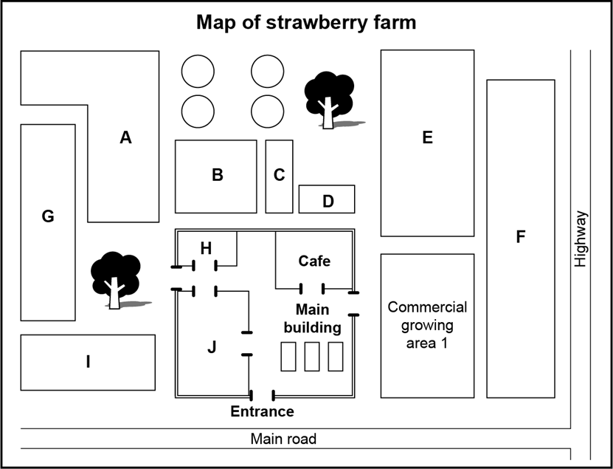

 | A | B | C | D | E | F | G | H | I
15 Staff room
16 Administration
17 Packing shed
18 Staff car park
19 Ripe strawberries
20 Unripe strawberries

42听力还原集Vol.4-Test2-Part3 Product development presentation: mosquito net
Questions 21 – 25
Choose the correct answer.
21Edward heard about a type of mosquito net from
an administrator.
a doctor.
a friend
22Edward believes that mosquito nets were first used in
China.
Japan.
Egypt.
23Chemical treatment of mosquito nets in the mid-twentieth century
was first developed by a soldier.
made them potentially dangerous to users.
was made possible by modern textiles.
24The owners of present-day nets
are likely to find they have an unpleasant smell.
should avoid using them every night.
may have difficulty obtaining the necessary chemical.
25According to Edward, Olyset nets are better than other nets because they
remain effective for longer.
use a greater number of chemicals.
give protection against more types of insects.
Questions 26 – 30
Label the flow-chart below. Choose the correct answer and move it into the gap.
Seminar presentation
Context: need for anti-malarial products
Figures relating to:
• global incidence of the disease
• impact on national economies
↓
Mosquito nets
• history
• unique features of the product
↓
Production
• information about sources of funding
• profile of manufacturer with description of workforce
• production figures (according to website)

workforce
sources of funding
investment opportunities
unique features of the product
future developments
production figures
national economies

43听力还原集Vol.4-Test3-Part2 Information for Volunteers at Clifton Bird Park
Questions 11 – 15
Choose the correct answer.
11The speaker stresses the importance to Clifton Bird Park of
birds that are now endangered.
birds from all over the world.
birds that are common in the local area.
12People who volunteer to help with gardening at the park
must work at weekends.
need to come at least once a month.
will only be required in the busy season.
13According to the speaker, who would be the ideal gardening volunteer?
someone who can work independently
someone who is willing to work in any weather
someone who knows a lot about plants
14Volunteer guides will mainly be working with
international visitors.
local people from Clifton.
school groups.
15What is still required for the Maintenance Day at the bird park?
food and drink
transport
tools
Questions 16 – 20
The map has eight labels (A - H). Choose the correct label for each building

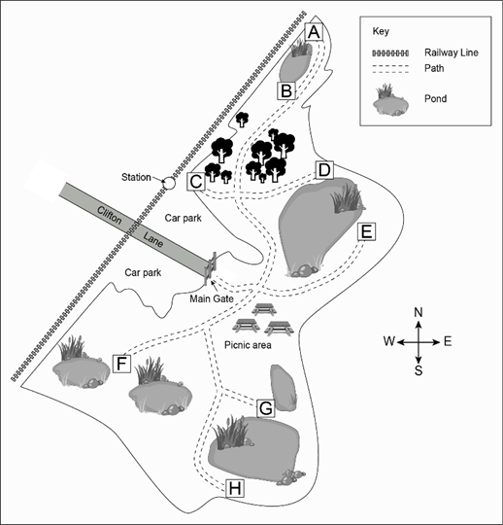

 | A | B | C | D | E | F | G | H
16 Wooden bridge
17 Observation tower
18 Visitor cabins
19 Nesting boxes
20 Boat sheds

44听力还原集Vol.4-Test4-Part2 Gym
Questions 11 – 12 Choose TWO correct answers.
11-12Which TWO parts of the gym are closed for part of the day?
the café
the weights room
the reception desk
the childcare centre
the shop
Questions 13 – 14 Choose TWO correct answers.
13-14Which TWO facilities have recently been updated?
the change rooms
the sauna
the treadmills
the car park
the yoga studio
Questions 15 – 20
The map has ten labels (A - J). Choose the correct label for each building

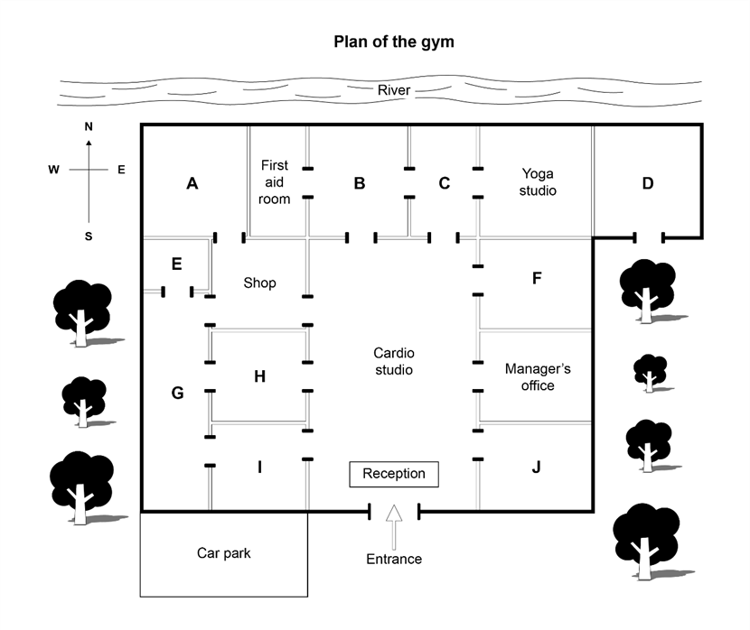
 | A | B | C | D | E | F | G | H | I | J
15 Personal trainers' office
16 Pool
17 Stretch area
18 Men's changing room
19 Weights room
20 Café

45听力还原集Vol.9-Test3-Part 3 Discussion on Nursing Course
Questions 21-24
Choose the correct letter, A, B or C.
21How old are the students on the nursing program?
They are teenagers.
They are in their twenties.
They belong to different age groups.
22What do the speakers say about the group project?
It helps to improve relationship among different classmates.
It helps to develop problem solving skills.
It provides supportive learning environment.
23Which part of the program surprised Paul?
There’s a number of essays to write.
There’s a lot of practical work.
There’s internship provided.
24What do they feel about learning law?
It is essential training.
It is too theoretical.
It takes up too much time.
Questions 25-30
What are the suggestions offered by the speakers?
Choose SIX answers from the box and write the correct letter, A-H, next to Questions 25-30.
A get feedback from teaching staff
B do more reading
C get help from school supporting staff
D get help for nursing problems
E manage time properly
F be well prepared
G review the notes regularly
H don’t set unrealistic goals
25. Essays
26. Lectures
27. Research
28. Online forum
29. Placement tests
30. Freshmen

46听力还原集Vol.8-Test 1-Part2 Photography club
Questions 11- 16
Choose the correct answer and move it into the gap.
Photography magazine
Camera Ready
Outdoor Lens
Photographer Today
Photo Now
Wild Photos
Photo Monthly
Comments

useful technical advice
easy to understand advice
free offers
reports about new products
advice about photography locations
high quality photos
only available online
monthly competitions

Questions 17 - 18
Choose TWO correct answers.
17-18Which TWO useful features of the Photo Safari tour does John mention？
the photography classes
having space to store equipment
the high standard of accommodation
the quality of the food
the airport pick-up service
Questions 19 - 20
Choose TWO correct answers.
19-20Which TWO opinions does John give about his holiday with Photo Safari？
Good advice was given about what clothes to take.
There were photo opportunities every day.
The non-photographers had a good time.
It was the best time of year to see the animals.
The guides knew a lot about photography.

47听力还原集Vol.7-Test 3-Part3 Oral History
Questions 21 - 25
Choose the correct answer.
21What source did Mike use for his definition?
a history textbook
an academic article
a lecture handout
22According to Mike and his tutor, what is the most important contribution of the internet to oral history?
the permanent preservation of recordings
an increase in student interest
wide access to the interviews by the public
23Mike says he chose his particular topic because
he is a football fan.
his father loves football.
his friends encouraged him.
24What does Mike say was his best source of information about the team?
doing research in the local newspaper archives
speaking to the team manager
looking at materials in the local library
25How did Mike find the former players he has arranged to interview?
on the internet
in the team records
in the phone book
Questions 26- 30
Choose the correct answer and move it into the gap.
Aspects of the proposed interviews
Questions drafted
Time allotted
Recording equipment used
Subjects chosen
Proposed report
Problems

too unreliable
too short
too noisy
too long
too formal
too factual
too complicated
too vague

48听力还原集Vol.7-Test 2-Part3 Shampoo Marketing Project
Questions 21 - 26
Choose the correct answer.
Shampoo Marketing Project
21Janet says that over time, shampoo has become
a cheaper product.
more hygienic in its effects.
a different kind of commodity.
22What does Janet say about bad hair days?
They really do exist.
Women worry about them more than men.
Their name is inaccurate.
23What do Janet and Michael say about the chemicals used in shampoos?
All shampoos contain the same chemicals.
The chemicals are believed to be dangerous.
The presence of the chemicals is rarely publicised.
24According to Janet, printing directly onto shampoo bottles, rather than onto labels
costs more.
looks less attractive.
takes a lot longer
25With regard to environmental issues, Michael and Janet want to investigate
the appearance of shampoo bottles.
variations in the weight of shampoo bottles.
the source of recycled plastic in shampoo bottles.
26Michael bases his own shampoo purchase decisions on his
loyalty to certain brands.
desire to get value for money.
willingness to try new products.
Questions 27- 30
Choose the correct answer and move it into the gap.
Shampoo advertisements
Zing
Splash
Just go
Brozene
Advertising focuses

link to relaxation
enviable lifestyle
natural ingredients
masculine image
product reliability
romantic interest
use by celebrities

49听力还原集Vol.6-Test 4-Part2 A talk by a fire safety officer
Questions 11 - 12
Choose TWO correct answers.
11-12
In which TWO types of accommodation are serious fires in Auckland most likely to happen?
houses which are unoccupied
houses in poorer areas
old buildings
wooden houses
rented accommodation
Questions 13 - 14
Choose TWO correct answers.
13-14
For which TWO reasons are housefires not reported quickly?
Witnesses assume they have been reported.
Residents are often asleep at the time.
Residents think they can put the fire out.
Warning equipment in the house has failed.
Faulty fire extinguishers result in wasted time.
Questions 15 - 16
Choose TWO correct answers.
15-16
Which TWO causes of house fires are people least aware of?
matches
cooking oil
portable heaters
electrical overload
candles
Questions 17- 20
Choose the correct answer and move it into the gap.
Aspects of fire safety
installing smoke alarms
discussing escape plans
cleaning smoke alarms
advice about locations for smoke alarms
Comments

often postponed
more important in large houses
best done regular
often forgotten
free
the subject of disagreement
easier than people think

50听力还原集Vol.6-Test 3-Part2 Visiting Marelia
Questions 11 - 20
Choose the correct answer.
11Your tips for taxi drivers and tour guides should be
as generous as possible.
as much as you feel is right.
approximately 10% of the fee.
12If you need medical help,
be aware that there is a charge.
call your medical insurance provider.
ask to see the hotel doctor.
13Water from the tap
contains no minerals.
may be unsafe to drink.
has an unusual taste.
14Bottled water is
sold everywhere.
often just tap water.
rather expensive.
15Buses on the island are
frequent.
punctual.
comfortable.
16You will always know where a bus is going by
looking at the number on the front.
checking with the driver.
reading the sign at the bus stop.
17If you need to hire a car, it is recommended that you
compare rates before booking.
take advice from your hotel.
book online before you go.
18When you go to collect your hire car, make sure you know
what to do if it breaks down.
what is covered in the price.
what special offers are available.
19What is the best way to get a taxi?
by phoning a local firm
by going to a taxi rank
by stopping one in the street
20What advice is given about taxi fares?
Refuse to pay more than the price on the meter.
Be prepared to pay more for late-night services.
Agree the price with the driver in advance.

51听力还原集Vol.6-Test 3-Part3 Environmental science course
Questions 21- 26
Choose the correct answer and move it into the gap.
Environmental Science modules
Statistics for environmental research
Sewage and drainage systems
Agriculture and food security
Sustainable energy
Government policy
Water management
Opinions

was surprisingly interesting
covered too many topics
included out-of-date materials
involved practical applications
supplied useful technical information
was too basic to be useful
provided unnecessary detail
was relevant to a topic in the news
seemed too limited geographically

Questions 27 - 28
Choose TWO correct answers.
27-28
Which TWO aspects of the course organisation did both Jamie and Martha like?
the amount of reading
the flexibility in the length of the course
the convenience of choosing when to take modules
the range of different modules offered
the relevance of the module content
Questions 29 - 30
Choose TWO correct answers.
29-30
Which TWO suggestions for the written assignment do Jamie and Martha agree to recommend to Dr Brown?
The time for choosing a topic should be changed.
The permitted word limit should be increased.
Discussions with fellow students should be arranged.
Face-to-face feedback sessions with the tutor should be scheduled.
Tutors should give more help in topic selection.

52听力还原集Vol.6-Test 2-Part2 The Middletown Urban Farming Scheme (MUFS)
Questions 11 - 16
Choose the correct answer.
The Middletown Urban Farming Scheme (MUFS)
11Who founded the Middletown Urban Farming Scheme?
university specialists
business people
town planners
12What was the original reason for starting the MUFS?
to encourage more efficient land use
to help lessen CO2 emissions
to improve people's eating habits
13For the coming year, the MUFS will focus on recruiting members from
schools.
companies.
community centres.
14What kind of information is available from members of the MUFS committee?
practical gardening tips
plant science
location of local garden sites
15What are provided by the MUFS for the physically disabled?
soil and compost
containers for plants
gardening tools
16According to school teachers, what has been an unexpected advantage of the MUFS?
its usefulness as an aid for teaching science
its contribution to reducing costs of school meals
its help in encouraging community pride among students
Questions 17- 20
Choose the correct answer and move it into the gap.
Providers
city hospital
local government
university
supermarket
Free goods or services

fertilisers
cooking lessons
advice on soil
eat-to-keep-fit course
use of a greenhouse
market stalls

53听力还原集Vol.6-Test 2-Part4 Effect of digital world on young
Questions 31 - 33
Choose the correct answer.
31What impact does Marc Prensky believe that digital technology has had on young people?
It has altered their thinking patterns.
It has harmed their physical development.
It has limited their brain capacity.
32'Digital immigrants' tend to access computers
using their native language.
less efficiently than young people.
for less important information.
33What example is given of having a 'digital accent'?
having less effective typing skills
doing things the old-fashioned way
being unable to understand instructions
Points made
Current teaching methods don't work.
Many students don't understand computers.
Computer technology doesn't interest all students.
Students can still learn the traditional way.
Students still need to learn research skills.
We should use computer games to teach.
Computers can't replace educators.
Theorists

Allen
James
Vander

54听力还原集Vol.5-Test2-Part2 Queensland Festival
Questions 11 - 16
Choose correct answer.
Queensland Festival
11Why does Jane recommend visiting the Music Tent on Tuesday?
There will be free entry.
There will be fewer people.
There will be special classes.
12When do the educational workshops take place in the Music Tent?
weekends only
every evening
every afternoon
13Why does Jane recommend going to the library to buy a ticket?
The tickets will be cheaper there.
You can get tickets in advance there
It's easier to get tickets there than in the city
14What will history lovers find interesting about Macquarie House?
its gardens
its architecture
its location
15The Big Barbecue is different this year because
it will be much larger than before.
there will be free entertainment.
the food will be cooked by international chefs.
16What can you do at the Railway Museum?
see a steam engine working
dress up in a railway worker's uniform
have a meal inside an old train
Questions 17 - 18
Choose TWO correct answers.
17-18
Which TWO free things does the family ticket on the steam train include?
an educational talk
a children's book
a short film
a flag
a tour of the lpswich Museum
Questions 19 - 20
Choose TWO correct answers.
19-20
Which TWO things apply when voting for Our Favourite Place？
People of any age may vote.
You may send in your vote by email.
Only local residents may vote.
You may vote several times.
Voting ends at midnight on Saturday.

55听力还原集Vol.5-Test2-Part3 Peter De Wint
Questions 21 - 26
Choose correct answer.
Peter De Wint
21What does Tina say about background information concerning De Wint？
The main biographical details were provided by his wife.
There is a wide range of sources available.
New evidence has recently been found.
22According to Dave and Tina, why did De Wint not sign his pictures？
He felt signatures were distracting.
He was unaware of the risk of forgeries.
He thought that his style identified his pictures as his own.
23A professor disapproved of De Wint's engravings of Oxford University because he thought
they were unattractive.
they were produced too quickly.
they weren't close likenesses of the actual buildings.
24What point does Tina make about De Wint's pictures of the Lincoln area
His work there helped to raise the profile of the area.
He found more to paint there than other artists might have done.
He was better at painting hills than his contemporaries were.
25Why does Dave feel that describing De Wint as 'Lincoln's artist' isn't accurate？
Relatively few of De Wint's pictures are of Lincoln.
De Wint liked other cities more than Lincoln.
Better artists than De Wint have lived and worked in Lincoln.
26When discussing Keats and De Wint, Tina criticises Dave for
not having done enough research.
misinterpreting the work of John Lord.
accepting one scholar's opinions too readily.
Questions 27 - 30
What comment is made about each of the following paintings?
Choose the correct answer and move it into the gap.
Torksey Castle
Still Life
The Cricketers
Burning of the Houses of Parliament
Comments

depicts an idealised view of rural life
was perhaps painted from memory
shows an event that never happened
probably produced as a teaching aid
highlights a contrast between past and present
was done in collaboration with another artist
has inconsistent painting styles in the same picture

56听力还原集Vol.5-Test3-Part3 Geology field trip to Iceland
Questions 21 - 25
Choose correct answer.
Geology field trip to Iceland
21Why do Andrew and Sarah decide to mention the Mountain Code?
It is the most relevant to their field trip.
It also applies to caves.
It covers the whole country.
22Andrew suggests some field trip participants harm the environment because
they fail to recognise rare species of plant.
they don't realise how fragile the environment is.
they get too absorbed in their tasks.
23Which rule about taking samples is most important?
Leave the area in its natural state.
Avoid removing fossils.
Keep collecting to a minimum.
24Which aspect of taking samples do they still have to find out about?
taking them from private land
taking them from rock faces
taking them from man-made structures
25What danger in coastal areas do they decide to emphasise?
falling rock
tidal movements
unstable sand
Questions 26 – 30
Which topic does each of the following reading packs focus on?
Choose the correct answer and move it into the gap.
Geothermal Fields
The Hot Spot
Glaciers
Basalt Rock
Geothermal Power Plants
Topics

unique geological features of Iceland
replacement of fossil fuels
negative changes due to human activity
energy for agriculture
health risks of eruptions
risk of flooding
long-term effects of volcanoes

57听力还原集Vol.5-Test4-Part3 A survey on music students
Questions 21 and 22
Choose TWO correct answers.
21-22Which TWO points did students most frequently make about their musical background before starting a music degree?
They had already composed music.
They had several music qualifications.
They could play more than one instrument.
They had performed in public.
They had had piano lessons.
Questions 23 and 24
Choose TWO correct answers.
23-24Which TWO points did students most frequently make about music practice?
They prefer to practise alone.
They try to practise every day.
They are motivated to practise by fear.
They feel they don't do enough practice.
They enjoy the challenge of a difficult piece.
Questions 25 and 26
Choose TWO correct answers.
25-26Which TWO points were most frequently made by students about the pieces they select for assessed performances?
They like to hear others performing the same pieces.
They like to choose little-known pieces.
They like to play pieces from memory.
They like their tutor to choose their pieces.
They like to choose technically demanding pieces.
Questions 27 – 30
Which comment did most students make about each of the following aspects of performance？
Choose the correct answer and move it into the gap.
Performing solo
Deciding which pieces to perform
Performing with musicians from a different genre
Performing with musicians who play the same instrument
Student comments
This is very beneficial.
This is difficult but enjoyable.
This can affect relationships.
This makes them very nervous.
This is time-consuming.
This is easy.
This happens infrequently.

58听力还原集Vol.4-Test1-Part3 Career Mentoring Programme
Questions 21 – 26
Choose the correct answer.
21How did Jack and Kate first learn about the career mentoring programme?
from the college website
from another student
from their tutor
22What criticism do both students have of the initial meeting about the programme?
The venue was inconvenient for them.
The information about the time commitment was unclear.
Some of what they were told was irrelevant.
23Most mentors decided to take on this role because they
wanted to encourage others to join their own profession.
had positive experience of working with young adults.
wanted to make a contribution to the university they had attended.
24What did Jack enjoy about the way he contacted his mentor?
having the opportunity to think before responding
being able to work when it suited him best
being able to see her as they spoke
25What was difficult for Kate about her first contact with her mentor?
deciding what she hoped to achieve from it
feeling she had said something foolish
explaining the details of her situation
26Jack says his mentor made him change his mind about
his plan to work in France.
his choice of modules for his final term.
his selection of topic for his dissertation.
Questions 27 – 28
Choose TWO correct answers.
27-28Which TWO topics did both students discuss with their mentors？
preparing a CV
their own strengths and weaknesses
choosing a post-graduate course
making a long-term plan
interview techniques
Questions 29 – 30
Choose TWO correct answers.
29-30Which TWO things do Kate and Jack think the mentoring programme should do with future students?
begin with a meeting between mentors and students
match mentors with students more carefully
start earlier in their course
restrict each mentor to working with just one student
provide some guidance for mentors

59听力还原集Vol.4-Test2-Part2 Gisborne
Questions 11 – 16
Choose the correct answer.
11The announcer says that the main topic of today's talk will be Gisborne's
economy
history
tourism
12The Maori name for the Gisborne region signifies
dangerous journey
east coast
sailing boat
13Early exports from Gisborne came from its
farms
fisheries
forests
14According to the speaker,what does Gisborne export to Asia nowadays?
oranges and lemons
red and white grapes
seafood and shellfish
15The Gisborne Summer Concert takes place in
an opera house
a vineyard
a Maori meeting house
16On wet days in Gisborne the announcer recommends
a cultural display in the museum
a fashion show in the town hall
a photography exhibition in the art gallery
Questions 17 – 20
Which group of people is each of the following attractions recommended for? Choose the correct answer and move it into the gap.
Attractions
Hot Springs Reserve
Mahia Peninsula
Motu River Rafting
Eden Woodlands Park

disabled people
elderly people
recently married couples
pregnant women
secondary school children
young school children
young adults

60听力还原集Vol.4-Test3-Part3 Research for assignment of children playing outdoors
Questions 21 – 22
Choose TWO correct answers.
21-22What do the speakers agree are the TWO reasons why children play outdoors less now than in the past?
concerns about traffic
limited outdoor play facilities
increased time spent online
preference for indoor play
reduction in free time
Questions 23 – 24
Choose TWO correct answers.
23-24In his assignment, which TWO aspects of outdoor play does Ravi want to focus on?
how it helps children to evaluate risk
how it broadens their horizons
how it aids children's muscular development
how it improves children's digestion
how it teaches children about the environment
Questions 25 – 26
Choose TWO correct answers.
25-26According to Ravi, in which TWO ways are children's periods of outdoor play now different from a generation ago?
They are less dangerous.
They involve fewer children.
They usually last a shorter time.
They include fewer made-up games.
They involve fewer chasing games.
Questions 27 – 30
Choose the correct answer.
27Ravi thinks parent should be more concerned about the decline of outdoor play because
it affects family relationships.
it leads to health problems later in life.
it makes childhood less enjoyable.
28What does Ravi say that schools should do with regard to outdoor play?
revise their aims
spend more money on it
listen to the views of parents
29What did Smith and Barker say about children in rural area?
They tend not to be allowed on farmland.
They receive more supervision out of doors.
They spend more time outdoors than city children.
30What problem do Dr. Chang highlight about Smith and Barker's area？
Its findings are inconclusive.
It is too old to be useful.
Its focus is limited.

61听力还原集Vol.4-Test4-Part3 Field trip to Bolton lsland
Questions 21 – 24
Choose the correct answer.
21Why were Mark and Stella attracted to Bolton Island for their field trip?
because it is geologically unique
because it is easily accessible
because it is largely unstudied
22Which aspect of Bolton Island's physical geography did Mark and Stella focus on?
its natural harbour
its fertile soil
its rock formations
23Which problem did Mark and Stella have in studying Bolton Island's physical geography?
getting useful information from the local residents
recognising which features were man-made
finding official data about the island
24What preparation was most useful for Mark and Stella's trip?
reading previous field trip reports
drawing up a detailed schedule for their trip
doing online research
Questions 25 – 26
Choose TWO correct answers.
25-26Which TWO mistakes did Mark and Stella make with their visuals？
not taking enough care when making sketches
not ensuring their photos had proper lighting
not using anything to indicate the scale of their photos
not making multiple photos and drawings of things of interest
not adequately recording when and where drawings were made
Questions 27 – 28
Choose TWO correct answers.
27-28Which TWO things does Stella say students need to do for a successful interview？
Guide the way in which the interview progresses.
Prepare the questions well in advance.
Check the recording equipment is working
Explain fully the purpose of the interview.
Give a personal opinion on the topics which are covered
Questions 29 – 30
Choose TWO correct answers.
29-30Which TWO things do Mark and Stella suggest doing with regard to note-taking on a field trip？
Ensure that terminology is correctly used in the notes.
Check your notes every evening.
Be highly selective in what you write down.
Have only one member's a team to write notes.
Keep your notes in an organised fashion.

62听力还原集Vol.5-Test1-Part3 Education House
Questions 21 - 26
Label the diagram below. Choose the correct label in each gap.

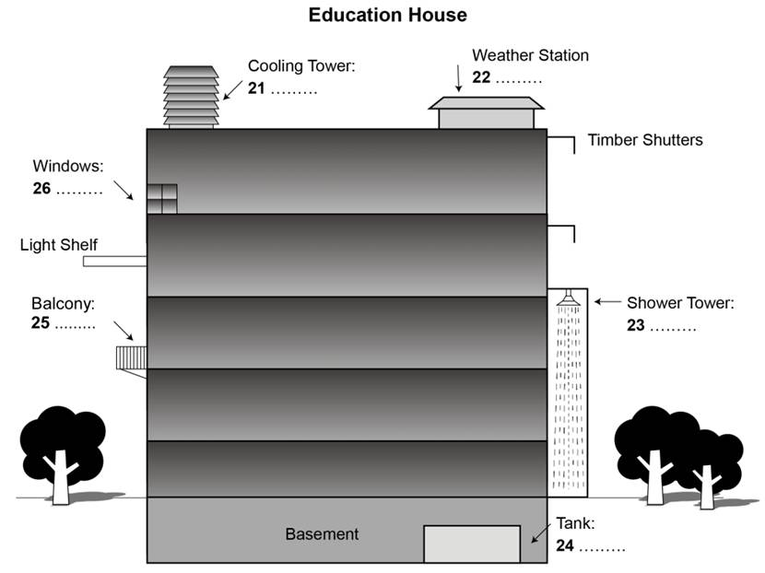
Cooling Tower:
Weather Station
Shower Tower:
Tank:
Balcony:
Windows:

fresh air is removed
fresh air is pulled in
heat loss is reduced
rainwater is checked
rainwater is used
old air is removed
temperature is checked
water temperature is reduced
water is stored

Questions 27 - 30
Choose correct answer.
27What do John and Debbie think will surprise visitors to the Education House building？
how high the building is
where the main entrance is
what is on the outside walls
28What is their reaction to the findings on staff productivity in the building？
They think the findings are predictable
They believe more research should be done
They suggest the findings are reported in the media.
29What do they think about the 'edge space' in the building？
It might be unpopular with staff.
It is a surprising part of the design.
It is an area for managers.
30What could be a problem for the building's water system？
the reaction of the staff
the completion date
the possible health hazards

63听力还原集Vol.5-Test4-Part2 The Beach Races
Questions 11 – 16
Choose the correct answer.
11Which is the most popular race?
bicycles
old tractors
motorbikes
12What does the official say about the horse race?
keep the finish line clear
keep spectators off the beach
keep boats away from the shore
13The Beach Picnic is only for
race competitors.
ticket holders.
children.
14The official says that parking
is more expensive for trucks.
costs the same as last year.
is free for some vehicles.
15What do stall-holders need to display?
a council licence
their registration form
an insurance certificate
16What final advice does the official give the volunteers?
encourage visitors to donate money
keep strictly to the timetable
eat and drink regularly
Questions 17 – 20
The map has nine labels (A - I). Choose the correct label for each building.
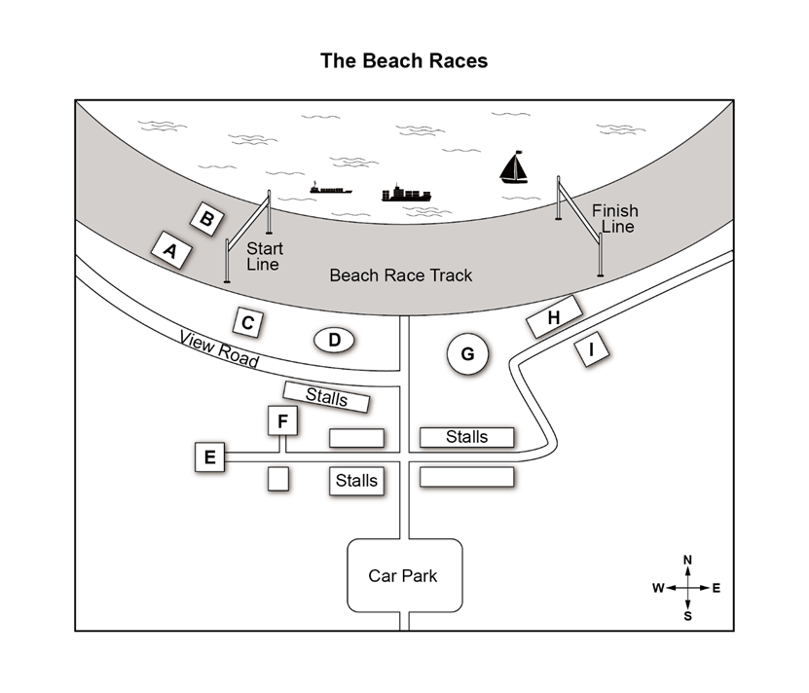
 | A | B | C | D | E | F | G | H | I
17 Admin Tent
18 Lost Property
19 Sandcastle Competition
20 First Aid

